LIFE INSURANCE DATABASE MANAGEMENT SYSTEM
A Database Design and Implementation Report

NYANGOMA CHRISTINE
2025/BCS/152/PS
Database Management Systems

1. Executive Summary
This report presents the design and implementation of a Life Insurance Database Management System (LIDBMS) developed using MySQL. The system is intended to support the core operational needs of a life insurance company by providing a structured, relational database that efficiently stores, retrieves, and manages data related to customers, insurance policies, agents, premium payments, and insurance claims.
The database was designed following standard relational database design principles, including entity-relationship modelling, normalization up to the Third Normal Form (3NF), and the enforcement of data integrity through primary and foreign key constraints. The system comprises five interrelated tables: customer, policy, agent, payment, and claim. Each table captures a distinct business entity with well-defined attributes and relationships.
The implementation was carried out on MySQL Community Server version 9.6.0. The database named life insurance was created and populated with sample data representing real-world scenarios of customers holding life insurance policies, agents managing commissions, payments made toward policies, and claims filed against them. The system demonstrates how a well-structured relational database can serve as a reliable back-end for insurance business operations.
Key outcomes of the project include a fully functional relational database schema, sample data inserted across all five tables, and demonstration of data retrieval using SQL SELECT queries. This report documents every phase of the project, from business justification through logical and physical design to full implementation with screenshots.

2. Business Case

Application Domain

System Name: Life Insurance Database Management System

2.1 Purpose and Motivation
Life insurance companies deal with large volumes of data on a daily basis. Managing information about policyholders, agents, premium payments, and claims manually or through fragmented systems leads to inefficiencies, data redundancy, errors, and poor customer service. A centralized, relational database management system provides a structured solution to these challenges.
The Life Insurance Database Management System addresses the need for a single, integrated repository that supports the daily operations of an insurance company. It enables accurate record-keeping, supports business decision-making, and improves data accessibility for authorized personnel.

2.2 Problem Statement
Without a dedicated database system, a life insurance company risks losing track of policyholder records, missing payment deadlines, failing to process claims in a timely manner, and being unable to monitor agent performance. These operational gaps translate into financial losses and poor customer satisfaction.

2.3 Objectives
The primary objective of this project is to design and implement a relational database system that:
- Stores comprehensive records of customers, including their personal and contact details.
- Maintains information about insurance policies, including their types, premium amounts, and validity periods.
- Tracks agents responsible for managing policies and their commission earnings.
- Records all payment transactions associated with policies.
- Manages insurance claims filed against policies, including claim status and amounts.

2.4 Expected Benefits (Tangible and Intangible Benefits)
Implementing this database system is expected to yield the following benefits:
- Elimination of data redundancy through normalized table structures.
- Improved data integrity through the use of primary and foreign keys.
- Faster retrieval of customer, policy, and claims data through structured SQL queries.
- Scalability to support a growing customer and policy base.
- A solid foundation on which application-layer software can be built in the future.

2.5 Scope
The scope of this project is limited to the design and implementation of the back-end relational database. It covers five main entities: Customer, Policy, Agent, Payment, and Claim. The system does not include a graphical user interface, though it is designed in a manner that would support one in future development phases.
- 2.6 Analysis of costs (Tangible and Intangible costs).
- Hardware (computers, servers)
- Software (MySQL)
- Development costs that is design and implementation
- Maintenance and update
- Training staff to use the system
- Time spent learning the system
- Resistance to change from employees.
- 2.7 User Issues.
Skill levels. Some users may have limited computer knowledge. It requires basic training.
Security awareness. Users must understand data privacy and protection.
- 2.8 Risk Assessment.
- System failure or bugs
- Data loss due to system crashes
- Cybersecurity threats for example hacking
- Resistance from staff
- Poor system implementation
- Incorrect data entry
- System down time affecting services.
- 2.8 Limitations of the system.
- Depends heavily on electricity and internet
- Cannot completely eliminate human errors
- Initial cost may be high
- Security risks if not properly managed
- Requires regular maintenance.

3. Design

3.1 Logical Design
The logical design phase involved identifying the entities, their attributes, and the relationships between them. An Entity-Relationship (ER) model was developed to provide a high-level conceptual view of the database structure.
Entities and Attributes:
Customer: CustomerID (PK), Name, Address, Phone, Age, Email
Policy: PolicyID (PK), PolicyType, PremiumAmount, StartDate, EndDate, CustomerID (FK)
Agent: AgentID (PK), Name, Address, Phone, Commission, customer_CustomerID (FK)
Payment: PaymentID (PK), PaymentDate, Amount, PolicyID (FK)
Claim: ClaimID (PK), ClaimDate, ClaimAmount, Status, PolicyID (FK)
Relationships:
A Customer can hold one or more Policies (one-to-many relationship between Customer and Policy). A Policy can have multiple Payments associated with it (one-to-many relationship between Policy and Payment). A Policy can also have multiple Claims filed against it (one-to-many relationship between Policy and Claim). An Agent is associated with a Customer, establishing an advisory or managerial link between the agent and the policyholder.
The ER diagram (as shown in Figure 1) visually captures these relationships using crow-foot notation. Dashed lines indicate optional (nullable) relationships, while solid lines indicate mandatory ones.
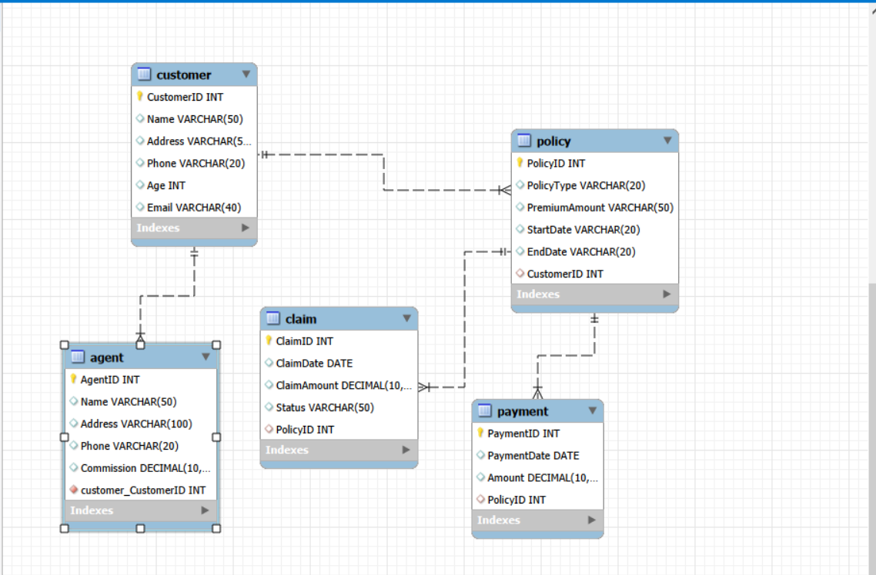
Figure 1: Entity-Relationship Diagram of the Life Insurance Database

3.2 Physical Design
The physical design translates the logical model into actual database objects in MySQL. The following design decisions were made:
All primary keys are of type INT with AUTO_INCREMENT, ensuring uniqueness and system-generated identity values. Foreign keys are used to enforce referential integrity between tables. Character fields use VARCHAR with appropriate length constraints. Monetary fields such as Premium Amount (in policy) and Commission (in agent) are defined as DECIMAL(10,2) where precision is required, or VARCHAR(50) in the policy table to accommodate varied formats present in the sample data. Date fields in the claim and payment tables use the DATE type, while Start Date and End Date in the policy table were stored as VARCHAR(20) to match the format of the data entered.
The database is hosted on MySQL Community Server 9.6.0, running locally. The database name is lifeinsurance, and it contains five tables: agent, claim, customer, payment, and policy.

4. Implementation

4.1 Database Creation and Table Structures
The life insurance database was created in MySQL and the following five tables were implemented. The screenshots below show the table descriptions as viewed from the MySQL command-line interface.

4.2 Table Descriptions
Table 1: agent
The agent table stores information about insurance agents, including their personal details and commission earnings.
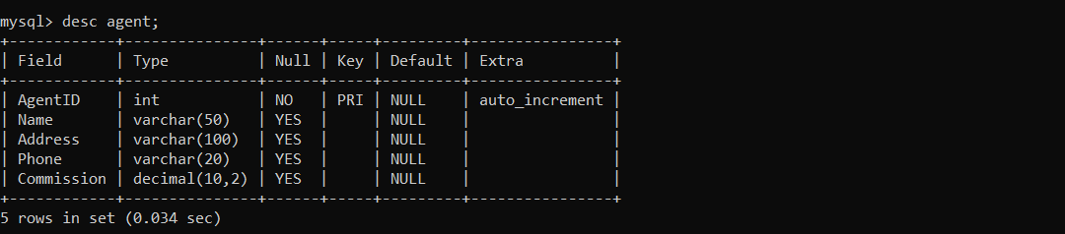
Table 2: claim
The claim table records insurance claims linked to specific policies. It tracks the claim date, amount, and current status.

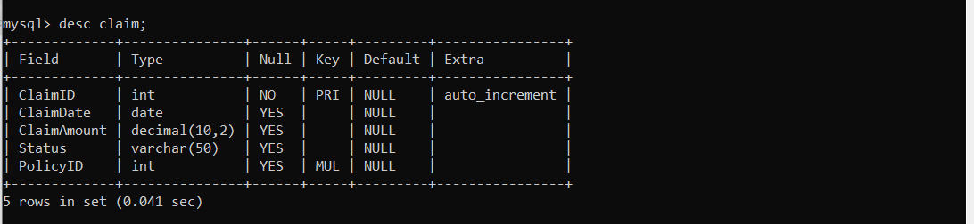
Table 3: customer
The customer table holds personal and contact information for each policyholder registered in the system.
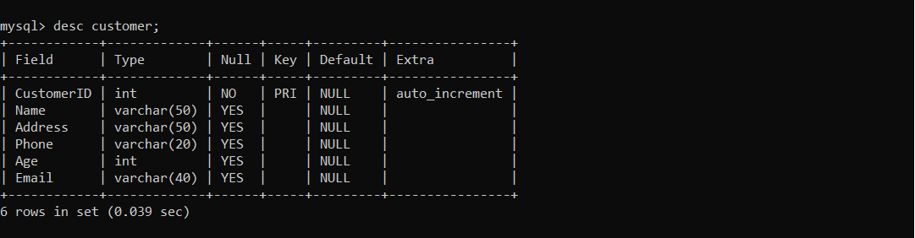
Table 4: payment
The payment table logs all premium payments made by customers in relation to their policies, recording the payment date and amount.
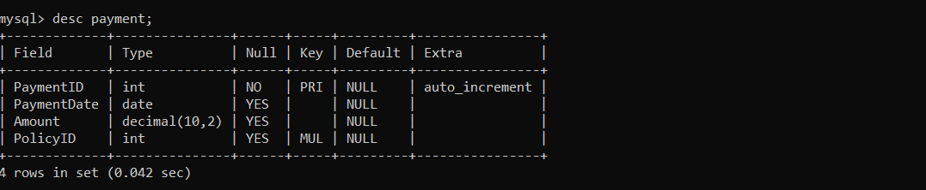
Table 5: policy
The policy table stores the details of each insurance policy, including its type, premium amount, coverage period, and the customer it belongs to.
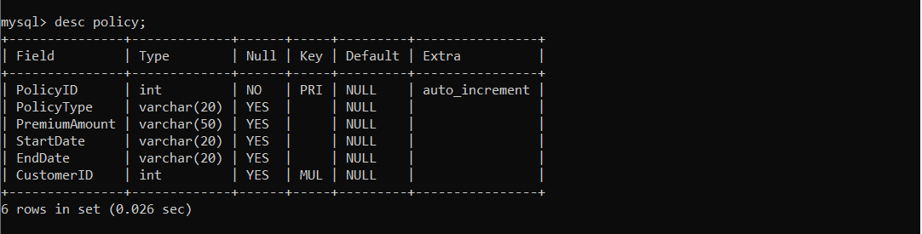

4.3 Sample Data and Query Results
Customer Data (SELECT * FROM customer)
The customer table contains three records representing registered policyholders from the western Uganda region.
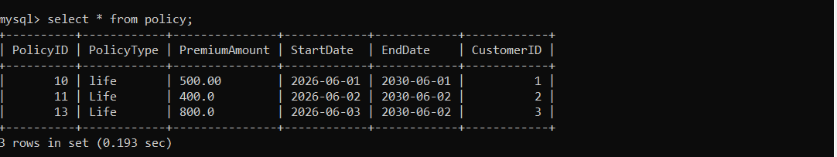
Policy Data (SELECT * FROM policy)
The policy table shows three active life insurance policies linked to each registered customer. All policies are of type Life and have a four-year coverage period.
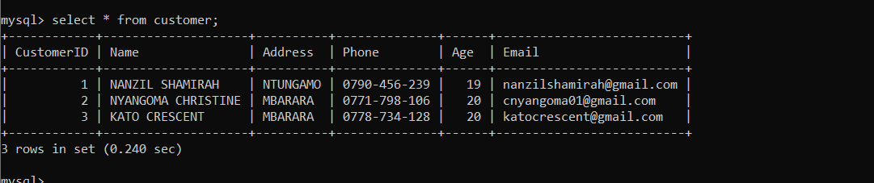
Agent Data (SELECT * FROM agent)
The agent table lists three agents responsible for managing customer policies. Their addresses are drawn from towns in western Uganda, and their commission amounts vary between UGX 500.00 and UGX 700.00.
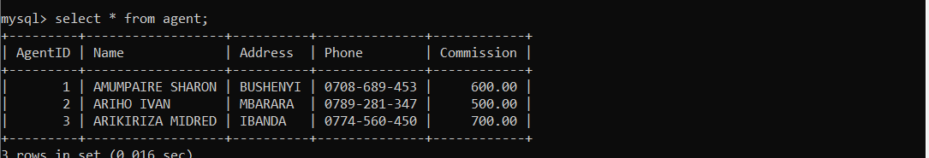

4.4 Screenshots
The following screenshots were captured from the MySQL command-line interface and MySQL Workbench during the implementation and testing phases of the project.
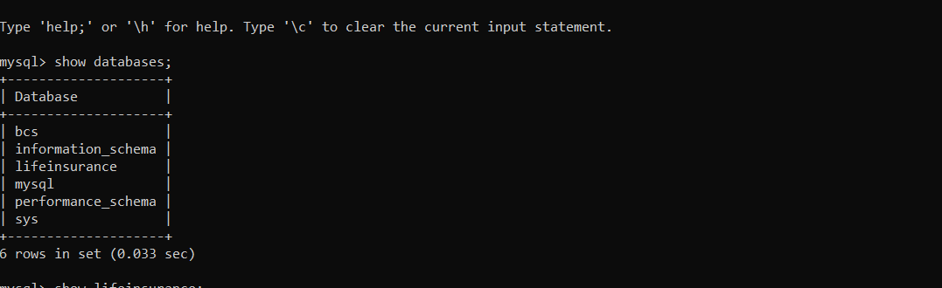
Screenshot 1: Output of SHOW DATABASES; confirming the lifeinsurance database exists alongside other system databases.
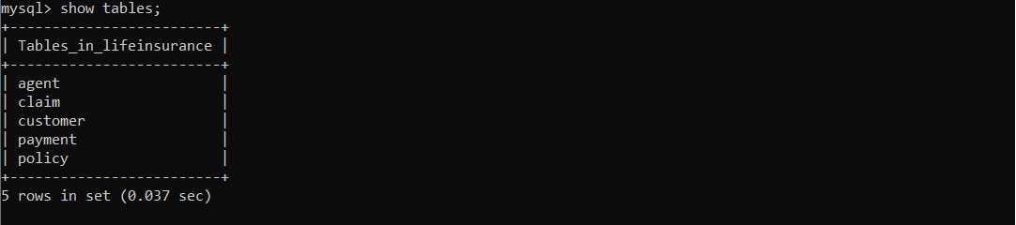
Screenshot 2: Output of SHOW TABLES; listing the five tables in the life insurance database.

Screenshot 3: DESC agent; showing the structure of the agent table.


4.5 SQL Queries Demonstrated
The following SQL queries were used during implementation and testing:
USE lifeinsurance;
Switches the active database context to life insurance.
SHOW TABLES;
Lists all tables within the life insurance database, confirming that agent, claim, customer, payment, and policy are present.
DESC <table name>;
Displays the column structure of each table, including field names, data types, nullability, key types, and extra attributes such as AUTO_INCREMENT.
SELECT * FROM <table name>;
Retrieves all records from the specified table. This was used to verify the correctness of data inserted into the policy, customer, and agent tables.

5. Bibliography
Connolly, T. & Begg, C. (2015). Database Systems: A Practical Approach to Design, Implementation, and Management (6th ed.). Pearson Education.
Elmasri, R. & Navathe, S. B. (2016). Fundamentals of Database Systems (7th ed.). Pearson Education.
Oracle Corporation. (2026). MySQL 9.6 Reference Manual. Retrieved from https://dev.mysql.com/doc/refman/9.6/en/
Silberschatz, A., Korth, H. F., & Sudarshan, S. (2020). Database System Concepts (7th ed.). McGraw-Hill Education.
Date, C. J. (2004). An Introduction to Database Systems (8th ed.). Pearson Addison Wesley.
MySQL Workbench. (2026). MySQL Workbench Manual. Oracle Corporation. Retrieved from https://dev.mysql.com/doc/workbench/en/

